MEDIA RELEASE
Aurora Expeditions Appoints Global Head of Sales
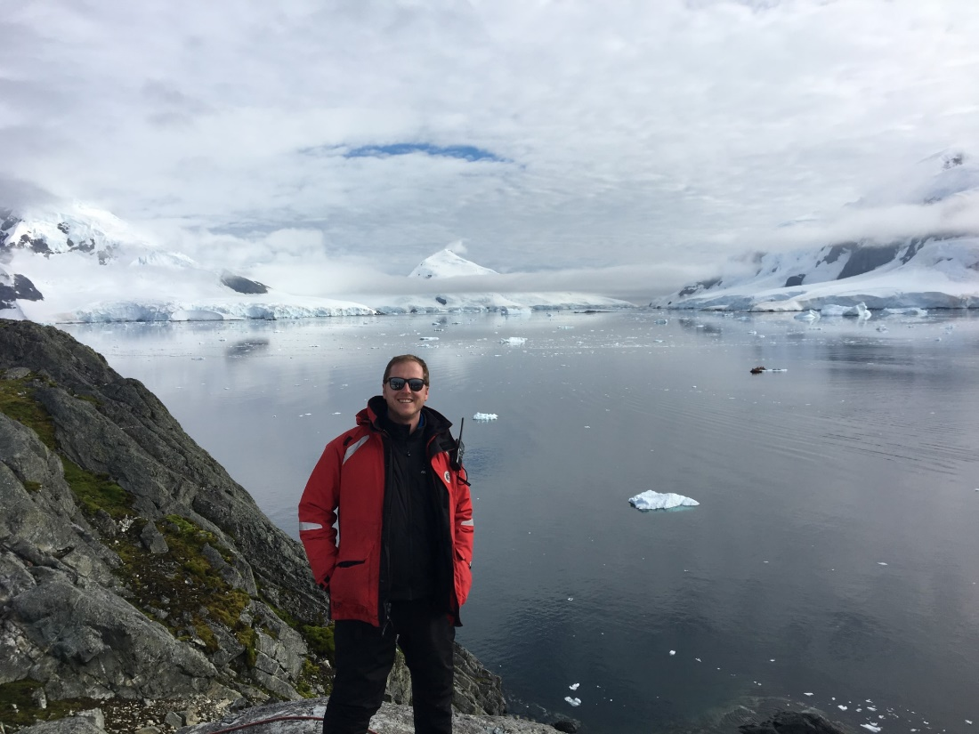

SYDNEY, AUSTRALIA 9 August 2023 – Aurora Expeditions, Australia’s leading expedition travel company, has today announced the appointment of David Tanguay, who joins the business as Global Head of Sales.
The newly created role will be responsible for driving revenue growth in Aurora’s key markets as well as developing its sales strategy for potential emerging markets.
Bringing more than a decade of sales experience within the polar expedition industry, David will work closely with the company’s regional leaders Lisa Bertini (VP of Sales, North America), Steve McLaughlin (Sales Director, APAC), Jos Dewing (Managing Director, EMEA) and their teams to grow Aurora’s market share and support the scaling of its operations.
Based in Toronto, David’s appointment also reflects the importance of the North American market to Aurora’s future growth plans, as it continues to raise its profile as a leading expedition operator amongst the region’s trade industry.
“I am incredibly excited to be joining a purpose driven organization who embeds sustainability into its global strategy,” commented Tanguay.
“Expedition travel has the power to make a positive impact by creating conservation awareness and giving back to communities. Aurora Expeditions is a pioneer in this space, and I look forward to working with Aurora’s talented global team to promote the life-changing experiences they have been offering for over 30 years.”
“David’s appointment comes at a pivotal time for Aurora Expeditions – we now have two purpose-built expedition ships, the Greg Mortimer and Sylvia Earle, and we have ambitious plans for our future growth,” commented Michael Heath, CEO.
“We’re looking forward to leveraging David’s expertise in the expedition space as well as his strategic acumen, and I’m confident he will be an invaluable addition to Aurora’s global team.”
For more information about Aurora Expeditions, visit www.aurora-expeditions.com
~ END ~

Media Contact
MMGY NJF
aurora@njfpr.com

Photo credit: Supplied

About Aurora Expeditions
Aurora Expeditions is an award-winning, Australian-owned expedition company pioneering experiential travel for over 32 years. A pioneer in Polar Expeditions, Aurora is deeply committed to environmentally respectful travel to preserve the beauty and majesty that mother nature possesses, and we take real actions for the care of the planet.

Founded on the guiding principles of adventure and endless exploration, the small ship experience is intimate and friendly. Aurora Expeditions takes travellers on perspective-altering experiences to some of the planet’s most remote and incredible places.

Aurora’s two purpose-built ships, Greg Mortimer and our brand-new small expedition ship Sylvia Earle are designed for global discovery.

