MEDIA RELEASE
Your Chance To Explore The Arctic For Free
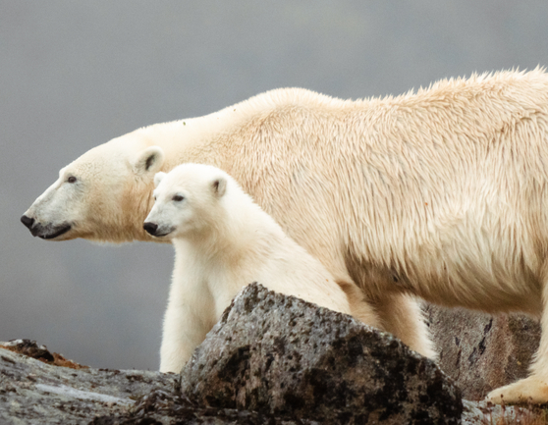
Win A Life-Changing Arctic Experience For Two Worth over £29,000 With AE Expeditions

SYDNEY, AUSTRALIA (18 May 2023) – Have you ever dreamed of exploring the unforgettable Arctic? Sailing the fjords, maybe spotting a polar bear, counting the variations of blue in icebergs or imagining yourself an explorer?

Now AE Expeditions is giving some lucky person the opportunity to win* a place for two on board one of its purpose-built intimate ships, the Greg Mortimer and recently launched Sylvia Earle in its Life-Changing Arctic Competition to the value of £29,790. Running from 18 May to 19 July 2023, the competition is open to anyone globally over the age of 18 years.

The winner can choose between three incredible departures: Iceland Circumnavigation, Jewels of the Arctic or Svalbard Odyssey, each departing in 2024. To win they just share their dream Arctic voyage with AE Expeditions and why in 25 words or less and they could be the lucky winner. The prize package* includes the selected voyage in a Balcony C Stateroom and money toward their airfare.

Jewels of the Arctic - 15 days departing 23 June or 07 July or 21 August 2024
Explore the Arctics highlights: visit Svalbard, with its rare Arctic wilderness and where a polar bear may have your pulse racing; East Greenland, sail into the world’s largest fjords, Scoresbysund and call on Ittoqqortoormiit, one of the world’s remotest Inuit settlements before ending in Iceland.

Svalbard Odyssey - 12 days Departing 19 June or 11 August 2024
Enjoy the best of Svalbard, a world of endless daylight where wildlife sightings can range from walruses, and whales to arctic foxes and polar bears, or discover historic camps of explorers. All while exploring the breathtakingly beautiful Norwegian fjords.

Iceland Circumnavigation 11 days Departing 21 May 2024
Explore the ‘Land of Ice and Fire’ where snow-capped peaks rise above glaciers and active volcanoes rumble. Walk along a black sand beach strewn or explore spectacular fjords and impressive waterfalls, in one of the most geologically active places on earth. It is also home to the largest seabird cliffs in Europe.
AE Expeditions is a multi-award-winning expedition travel company with over 32 years of exploration experience. It is a leader in life-changing, sustainable and respectful small-ship expeditions to the world’s most remote natural environments and through immersive and enriching experiences creating lifelong ambassadors of our planet.

For more information, visit www.aexpeditions.co.uk.
* Terms and conditions apply
-END-

Notes to Editors

Image credits: Tyson Mayr
Additional Images: https://library.aurora-expeditions.com/web/74bbcc12a728591a/arctic/
Please credit listed photographer

For all media enquiries:
Please contact Frangelica Flook
Cedar Tree Marketing & Public Relations
Phone: + 44 (0) 20 7978 4534
Mobile: +44 (0) 7747 606898
Email: Frangelica.flook@cedartreepr.com

NOTES TO EDITORS

About AE Expeditions

AE Expeditions is part of Aurora Expeditions headquartered in Sydney, Australia.

Aurora Expeditions is an award-winning, Australian-owned expedition company pioneering experiential travel for over 30 years. A pioneer in Polar Expeditions, Aurora is deeply committed to environmentally respectful travel to preserve the beauty and majesty that mother nature possesses, and we take real actions for the care of the planet.

Founded on the guiding principles of adventure and endless exploration, the small ship experience is intimate and friendly. Aurora Expeditions takes travellers on perspective-altering experiences to some of the most remote and incredible places on the planet.

Aurora’s two purpose-built ships, Greg Mortimer and our brand-new small expedition ship Sylvia Earle are designed for global discovery. Our new ship is named after acclaimed marine biologist, oceanographer, explorer and conservationist Dr Sylvia Earle.

For UK and Europe enquiries:
Please contact Jos Dewing
AE Expeditions Managing Director, EMEA
Email: jdewing@auroraexpeditions.co.uk
Phone: +44 (0)7773 455 497

