MEDIA RELEASE
So Much To Do … So Little Time

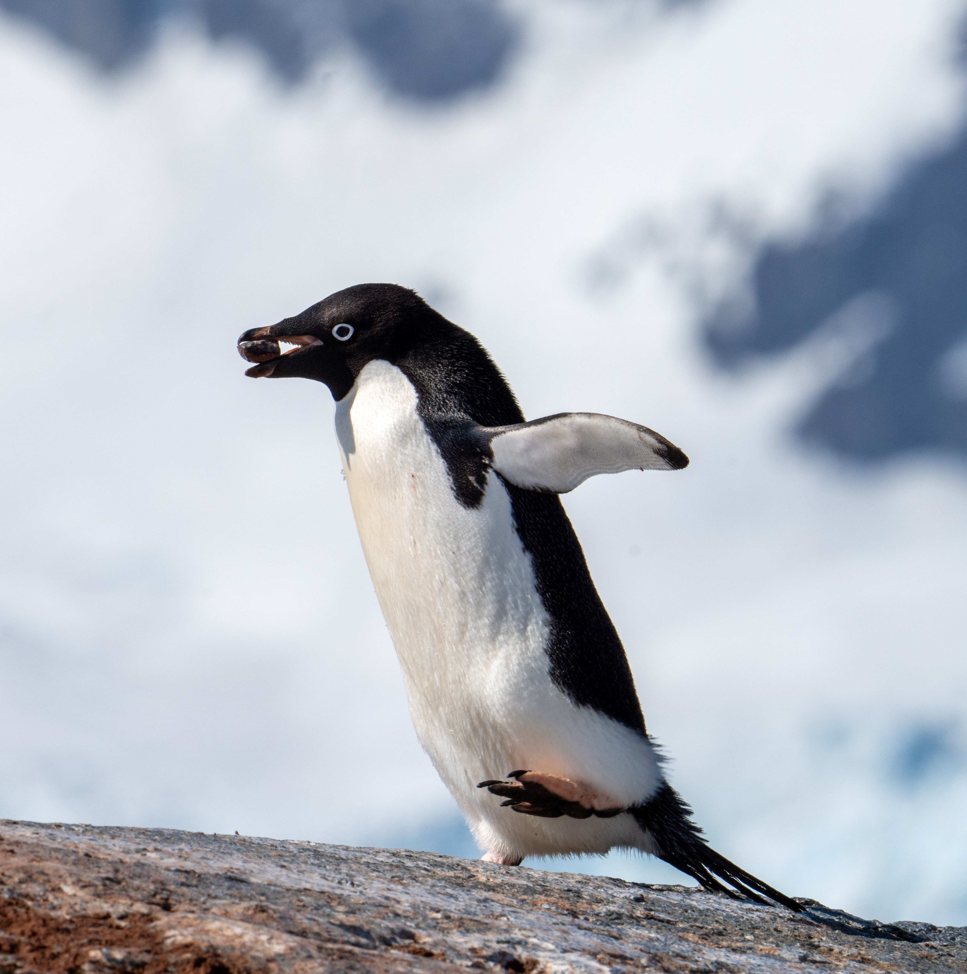

AE Expeditions’ Antarctic Explorer Express fits the bill with a limited-time offer

SYDNEY, AUSTRALIA (20 June 2023) – For busy travellers who wish to see and experience the Antarctic, Australia’s awarding-winning AE Expeditions (part of Aurora Expeditions) has the perfect solution for those short on time. It offers its shortest voyage, the Antarctic Explorer Express, a 9-day journey departing Ushuaia on 10 February 2024, onboard its latest purpose-built, small ship, the Sylvia Earle.

Travellers are guaranteed maximum adventure and more time off the ship with two to three landings per day (including a minimum of 3.5 days exploring the Peninsula). The Antarctic Explorer Express itinerary will start with a true rite of passage crossing the Drake Passage one way and returning by air, saving two days of travel after its Antarctic exploration.

AE Expeditions’ highly experienced Expedition Team each day will design a journey of discovery and enrichment with multiple Zodiac cruises and shore excursions each day capitalising on wildlife opportunities and amazing experiences. With days of 18 to 24 hours of daylight, passengers will have plenty of time to explore secluded bays, learn of the astonishing history and spot mesmerising icebergs and glaciers, all while watching out for the extraordinary wildlife from whales and penguins to seals and amazing birdlife. This Express voyage also offers the opportunity for sea kayaking, snorkelling or paddling activities.

For a limited time, AE Expeditions is offering a generous air credit of US$1000 per person on the Antarctic Explorer Express fly/sail voyage. When booked and a deposit paid before September 30, 2024, passengers can also save US$1309.50 per person (10%) in a Category C Balcony Stateroom.

AE Expeditions is also offering up to 25% savings* on its Special Guest and themed voyages and up to 15% savings* on its longer Antarctica voyages for the 2023/24 Antarctic season.

Travellers will need to act fast to secure the best rates and best staterooms as there is strictly limited availability on these offers. All offers must be booked and deposited before September 30, 2023, and are subject to availability, terms and conditions.
For more information, visit www.aexpeditions.co.uk
* Offers are subject to availability. Terms and conditions apply
-END-
Notes to Editors
Image credits: a busy Adelie penguin – Jamie Lafferty
Please credit the listed photographers

For all media enquiries:
Please contact Frangelica Flook
Cedar Tree Marketing & Public Relations
Phone: + 44 (0) 20 7978 4534
Mobile: +44 (0) 7747 606898
Email: Frangelica.flook@cedartreepr.com

NOTES TO EDITORS

About AE Expeditions

AE Expeditions is part of Aurora Expeditions headquartered in Sydney, Australia.

Aurora Expeditions is an award-winning, Australian-owned expedition company pioneering experiential travel for over 30 years. A pioneer in Polar Expeditions, Aurora is deeply committed to environmentally respectful travel to preserve the beauty and majesty that mother nature possesses, and we take real actions for the care of the planet.

Founded on the guiding principles of adventure and endless exploration, the small ship experience is intimate and friendly. Aurora Expeditions takes travellers on perspective-altering experiences to some of the most remote and incredible places on the planet.

Aurora’s two purpose-built ships, Greg Mortimer and our brand-new small expedition ship Sylvia Earle are designed for global discovery. Our new ship is named after acclaimed marine biologist, oceanographer, explorer and conservationist Dr Sylvia Earle.

For UK and Europe enquiries:
Please contact Jos Dewing
AE Expeditions Managing Director, EMEA
Email: jdewing@auroraexpeditions.co.uk
Phone: +44 (0)7773 455 497

