MEDIA RELEASE
Explore the Antarctic Ocean with AE Expeditions on World Oceans Day

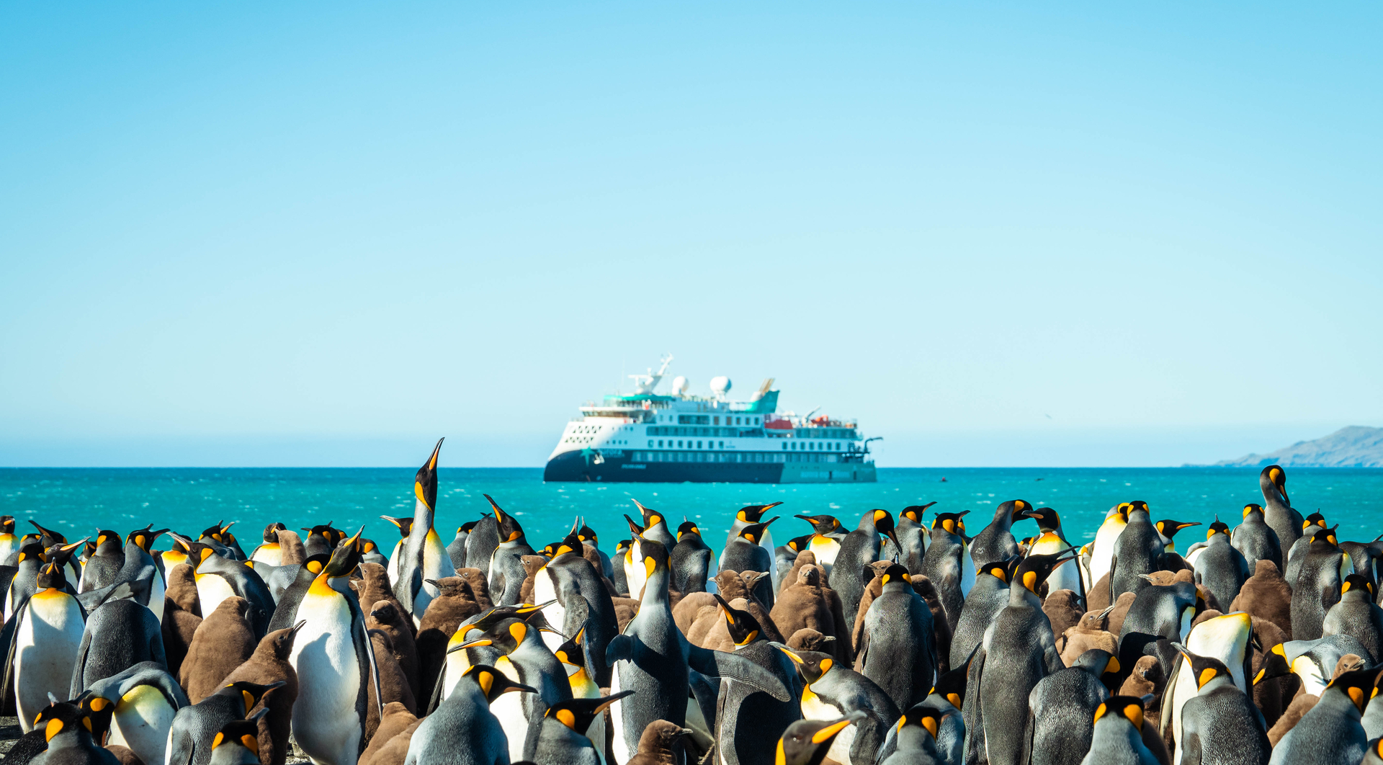

SYDNEY, AUSTRALIA (June 08, 2023) – In celebration of World Oceans Day, leading Australian expedition company AE Expeditions (part of Aurora Expeditions) announces its special limited-time-only offers on exceptional itineraries to Antarctica for the 2023/24 season for travellers to experience the spectacular Antarctic Ocean and its fascinating inhabitants.

World Oceans Day “is to inform the public of the impact of human actions on the ocean, develop a worldwide movement of citizens for the ocean, and mobilize and unite the world’s population on a project for the sustainable management of the world's oceans,” according to the United Nations.

“Thank you, Aurora for the approach that you use to keep people inspired about the ocean,” Dr Earle commented. “Exploring the ocean, using knowledge to take care of all this on our planet. I’m looking at Aurora as the voice of the ocean.”

AE Expeditions, since its inception 32 years ago, has been committed to responsible travel, encouraging our expeditioners to become ambassadors for the planet. We pride ourselves on innovation and pushing boundaries of discovery to provide unique, captivating experiences for our expeditioners while maintaining minimal evidence of our visit. Travel is an excellent educator and AE Expeditions is offering the chance to enrich our passengers’ curiosity through its current savings* for its Antarctic 2023/24 sailings valid from June 15, 2023.

AE Expeditions is offering an air credit of £500 per person* on its Antarctic Explorer Express. Departing Ushuaia, Argentina on February 10, 2024, onboard AE Expeditions’ latest purpose-built ship, the Sylvia Earle, the 9-day journey is ideal for travellers with limited time. This fly/sail voyage returns to Punta Arenas, Chile on February 18, 2024, and is priced from US$11,785.50 per person in a Balcony Stateroom Category C, a saving of US$1,309.50 per person (10%) however there is limited availability so be quick to book this voyage.

AE Expeditions is also offering up to 25% savings* on its Special Guest and themed voyages for this Antarctic season.
Those fascinated with the ill-fated Shackleton voyage will be keen to travel with Saunders Carmichael-Brown on its 14-day Deep Weddell following Nordenskjold departing March 24, 2024. During this journey, Saunders, an award-winning digital and broadcast presenter and producer with a background in adventure travel and sustainability, will regale his adventures of being an integral part of the team on the 2022 Endurance Antarctic Expedition that found Sir Ernest Shackleton’s famous shipwreck. Saunders was fundamental in broadcasting the expedition journey and updates to millions of viewers across the world.
Climate action enthusiasts will enjoy spending time with Don Maruska, entrepreneur and author, and AE Expeditions Special Guest on its 12-day Spirit of Antarctica departing December 11, 2023. Don is a respected business motivator and coach, specialising in sustainability actions. He’s written many books including How Great Decisions Get Made and Solve Climate Change Now: Do What You Love for a Healthy Planet.
Dynamic couple Jett and Kathryn Britnell will be AE Expeditions Special Guests on its 18-day Circle and Weddell voyage departing March 08, 2024. These intrepid explorers and marine conservationist scuba divers will help expeditioners with their underwater photography. Jett’s images have appeared on over 50 magazine covers.
Avid photographers can also join our other professional, award-winning photographer Special Guests Peter Eastway and Richard I’Anson to learn how to take exquisite shots in the Antarctic’s amazing light. Join Peter on the 12-day Spirit of Antarctica departing January 09, 2024, or the 24-day South Georgia & Antarctic Odyssey featuring South Sandwich Islands departing January 19, 2024. Join Richard on the 14-day Across the Antarctic Circle departing February 25, 2024
Also of interest to Shackleton enthusiasts is our Falklands, South Georgia & Antarctic Peninsula 21-day voyage departing November 15, 2023, where adventurous passengers can follow Shackleton’s crossing of South Georgia by foot while currently saving 10%.
Another special voyage offering a 10% saving is our Founder’s Voyage Across the Antarctic Circle departing December 14, 2023. Spend a white festive season with AE Expeditions’ founder Greg Mortimer as your Expedition Leader.
All traveller offers are valid from June 15, 2023, and must be booked and deposited before September 30, 2023, unless sold out prior.

For more information, visit www.aexpeditions.co.uk
* Offers are subject to availability. Terms and conditions apply
-END-
Notes to Editors
Image credits: Tyson Mayr
Please credit listed photographer

For all media enquiries:
Please contact Frangelica Flook
Cedar Tree Marketing & Public Relations
Phone: + 44 (0) 20 7978 4534
Mobile: +44 (0) 7747 606898
Email: Frangelica.flook@cedartreepr.com

NOTES TO EDITORS

About AE Expeditions

AE Expeditions is part of Aurora Expeditions headquartered in Sydney, Australia.

Aurora Expeditions is an award-winning, Australian-owned expedition company pioneering experiential travel for over 30 years. A pioneer in Polar Expeditions, Aurora is deeply committed to environmentally respectful travel to preserve the beauty and majesty that mother nature possesses, and we take real actions for the care of the planet.

Founded on the guiding principles of adventure and endless exploration, the small ship experience is intimate and friendly. Aurora Expeditions takes travellers on perspective-altering experiences to some of the most remote and incredible places on the planet.

Aurora’s two purpose-built ships, Greg Mortimer and our brand-new small expedition ship Sylvia Earle are designed for global discovery. Our new ship is named after acclaimed marine biologist, oceanographer, explorer and conservationist Dr Sylvia Earle.

For UK and Europe enquiries:
Please contact Jos Dewing
AE Expeditions Managing Director, EMEA
Email: jdewing@auroraexpeditions.co.uk
Phone: +44 (0)7773 455 497

