

MEDIA RELEASE

Aurora Expeditions’ Douglas Mawson
Named to Condé Nast Traveler 2026 Hot List

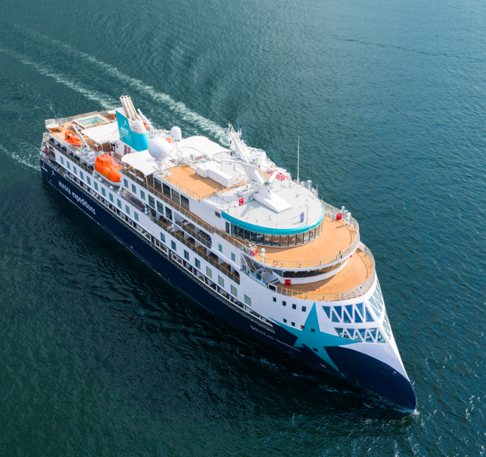

Download Images HERE

Sydney, Australia — 24 April 2026 — Aurora Expeditions today announced that its newest purpose-built expedition vessel, Douglas Mawson, has been named to the prestigious 2026 Hot List by Condé Nast Traveler, recognising the world’s best new hotels, restaurants and cruise ships.

Released annually each spring, the Hot List is curated by the publication’s global editorial team, who vet and select the most compelling new openings and travel experiences around the world. Inclusion in the 2026 list places Douglas Mawson among a highly selective group of standout travel experiences globally.

The recognition follows the successful debut season of Douglas Mawson, which has quickly established itself as a leading expedition vessel, purpose-built for immersive exploration across some of the world’s most remote regions — from Antarctica and the Ross Sea to the Arctic and beyond.

“We are incredibly proud to see Douglas Mawson recognised by Condé Nast Traveler as part of its 2026 Hot List,” said Katie Malone, Chief Marketing Officer at Aurora Expeditions. “This acknowledgement reflects the strength of our expedition offering — combining innovative ship design with meaningful, experience-led exploration, and a deep commitment to responsible travel.”

Designed specifically for expedition travel, Douglas Mawson builds on Aurora Expeditions’ legacy of small-ship exploration, offering expeditioners access to hard-to-reach destinations while maintaining a strong focus on sustainability, education and on-the-ground experiences.

The 2026 Hot List is published globally across Condé Nast Traveler’s digital platforms today, with winners also set to feature in upcoming print editions.

This latest recognition adds to growing global acclaim for Douglas Mawson following its inaugural season, further cementing Aurora Expeditions’ position as a leader in immersive, small-ship expedition travel.

~ENDS~

About Aurora Expeditions
Aurora Expeditions is an award-winning Australian-owned adventure travel company that has pioneered experiential travel for 35 years. A Certified B Corporation™️, a commitment to the protection and preservation of our planet is at the heart of each experience.

Founded on the guiding principles of adventure and endless exploration, our carefully curated small-ship voyages offer immersive activities, more time off ship and thoughtful enrichment programs in some of the planet’s most remote and incredible places.
Aurora’s three purpose-built small ships, Greg Mortimer, Sylvia Earle and Douglas Mawson are designed for global discovery.

