

MEDIA RELEASE

AURORA EXPEDITIONS’ NEWEST SHIP DOUGLAS MAWSON EARNS SPOT ON
TIME’S 2026 WORLD’S GREATEST PLACES LIST

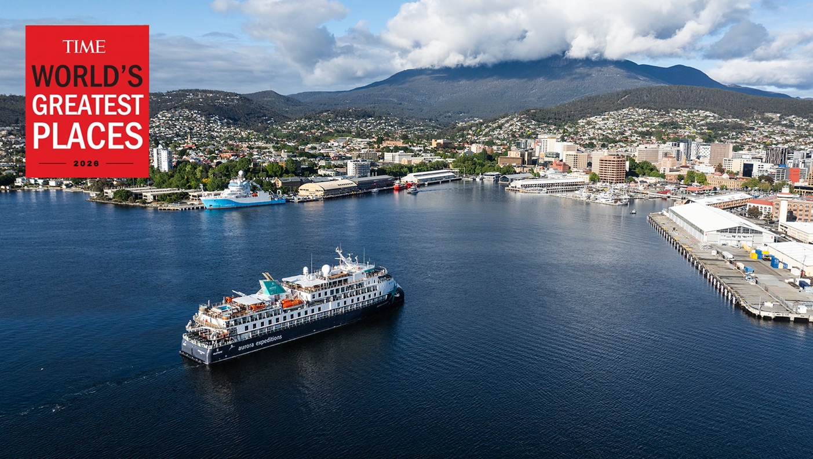

Sydney, Australia — 13 March 2026 – Australian-owned expedition operator Aurora Expeditions today announced that its newest purpose-built expedition vessel, Douglas Mawson expedition ship, has been recognised on the prestigious TIME World’s Greatest Places 2026 list.
Published annually by TIME, the list highlights the most remarkable destinations and travel experiences around the world — celebrating places that are shaping the future of travel through innovation, sustainability and cultural significance.
Launched in November 2025, Douglas Mawson is Aurora Expeditions’ newest purpose-built small ship and the third in its fleet designed specifically for exploration in some of the planet’s most remote regions. Named after legendary Antarctic explorer Sir Douglas Mawson, the vessel reflects Aurora’s longstanding connection to the history of polar exploration while showcasing the next generation of expedition travel.

Carrying just 130 expeditioners in polar regions (or up to 154 on global itineraries), the ship combines the intimacy of small-ship exploration with cutting-edge technology designed for responsible travel. At the heart of the design is Ulstein’s distinctive X-BOW®, a wave-piercing hull that improves stability, reduces fuel consumption and provides a smoother ride through rough seas — particularly important for crossings such as the Drake Passage.
Inside, the ship features light-filled spaces designed to connect travellers with the environments they explore, including a two-storey atrium, a panoramic forward-facing observation lounge, a citizen science centre and expansive outdoor decks for wildlife viewing and photography.
Purpose-built expedition infrastructure also supports Aurora’s immersive exploration style, with dedicated Zodiac embarkation platforms enabling fast access to shore landings and wildlife encounters. Sustainability and science are central to the ship’s design.
The vessel also includes dedicated spaces for onboard learning and research, including a Citizen Science centre and lecture theatre where expedition specialists share insights on wildlife, climate science and polar history.
“Being recognised by TIME as one of the World’s Greatest Places is an honour and reflects the growing global appetite for meaningful exploration,” said Katie Malone, Chief Marketing Officer at Aurora Expeditions. “Douglas Mawson was designed as a platform for discovery — bringing together adventure, science and responsible travel in some of the most extraordinary places on Earth.”
The ship joins Aurora Expeditions’ fleet alongside the Greg Mortimer and Sylvia Earle, enabling the company to operate expeditions across all seven continents.
In 2026, Aurora Expeditions celebrates 35 years of expedition travel, continuing its mission to take travellers beyond the familiar while fostering deeper connections with the natural world.
For more information, visit www.aurora-expeditions.com/au and for a full list of award winners visit time.com/collection/worlds-greatest-places/2026
~ENDS~
MEDIA CONTACT
Madeline Georgiadis
0455 932 164
About Aurora Expeditions
Aurora Expeditions is an award-winning Australian-owned adventure travel company that has pioneered experiential travel for 35 years. A Certified B Corporation™️, a commitment to the protection and preservation of our planet is at the heart of each experience.
Founded on the guiding principles of adventure and endless exploration, our carefully curated small-ship voyages offer immersive activities, more time off ship and thoughtful enrichment programs in some of the planet’s most remote and incredible places.
Aurora’s three purpose-built small ships, Greg Mortimer, Sylvia Earle and Douglas Mawson are designed for global discovery.

