

MEDIA RELEASE

Aurora Expeditions Sets Sail on its Largest European Small-Ship Cruising Season
SEAON LAUNCH OFFER: Companion sails free on selected voyages

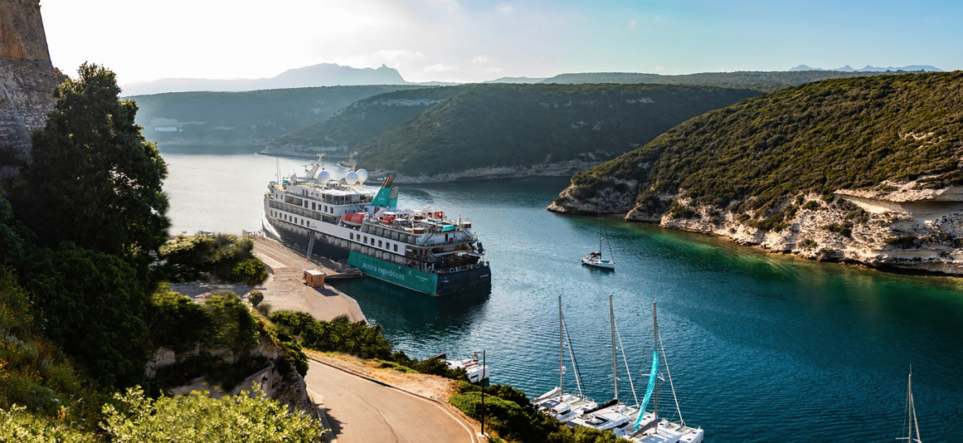
Download Images HERE

Sydney, Australia — 19 March 2026 – Aurora Expeditions’ largest European small-ship cruising season to date begins next month, with 19 voyages exploring more than 120 ports across the Mediterranean, Adriatic, Northern Europe and the UK & Ireland.

Operating from April to October 2026, the voyages will take place primarily aboard Aurora’s newest purpose-built ship, Douglas Mawson, bringing the company’s style of immersive, small-ship travel to destinations ranging from the Canary Islands and Portugal to the Greek Islands and Adriatic coast.

“We’re seeing growing interest in smaller ships and more immersive styles of travel, particularly in destinations where travellers are looking for deeper context and a stronger connection with the places they visit,” said Justin Ewin, Global Head of Product, Aurora Expeditions.

Known for its polar voyages in Antarctica and the Arctic, Aurora has long focused on journeys that prioritise insight, storytelling and time spent understanding a destination. The European programme builds on that philosophy, applying the same thoughtful approach to culturally rich regions.

Each itinerary is enriched by onboard Master Storytellers — historians, genealogists, art experts and cultural specialists — who explore the people, traditions and defining moments that shaped each destination. Ashore, all-inclusive Your Choice experiences allow travellers to personalise their time in port through curated excursions designed to reveal the character of each region.

SMALL SHIP ITINERARY HIGHLIGHTS:
Ireland: The Luck of the Irish
Dublin to Dublin, May 8-18, 2026 and June 16-27, 2027
Ireland’s rugged coastline is best experienced from the water, where dramatic cliffs, historic ports and quiet seaside towns reveal themselves one after another. This voyage explores both Ireland and Northern Ireland, with time spent discovering castles, coastal villages and storied landscapes while learning about the history, folklore and characters that have shaped the island’s culture over centuries.

Ireland & Scotland: Saints, Saviours and Secrets
Dublin to Edinburgh, May 15-28, 2026 and June 24 - July 7, 2027
This voyage explores the people and events that have defined the island, from religious figures and political leaders to writers, migrants and everyday citizens whose stories echo through Ireland’s towns and villages. Traveling through both the Republic of Ireland and Northern Ireland, the journey traces themes of faith, famine, independence and cultural identity, concluding with time in Edinburgh to explore Scotland’s own layered history.

Canary Islands to Lisbon: The Sands of Time
Santa Cruz de Tenerife to Lisbon, April 24 – May 7, 2026 and May 15-28, 2027
Travelers will discover the shared history of the Canary Islands, Morocco, Spain and Portugal, regions long connected through trade, migration and shifting empires. Stops range from the Canary Islands and the medinas of Morocco to the whitewashed towns of Andalusia, Gibraltar and Portugal’s Algarve coast, offering insight into the events and cultures that shaped the region, from the Moorish presence in Iberia to the Age of Exploration and its global impact.

The Amalfi, Sicily and Malta: The Godfather
Rome to Valletta, Malta, July 8 – 19, 2026 and May 10-27, 2027
Southern Italy, Sicily and Malta share a long and complex history shaped by competing empires, trade routes and cultural exchange. This voyage explores the Amalfi Coast, the island of Sicily and the historic ports of Malta, where ancient cities, clifftop villages and Mediterranean resort towns sit alongside archaeological sites and layers of political history. Along the way, travellers encounter stories ranging from Roman rule and buried cities to the cultural traditions, cuisine and everyday life that continue to define the region today.

The European small-ship cruising season forms part of Aurora Expeditions’ broader 2026/27 global programme, with its fleet of three purpose-built ships — Greg Mortimer, Sylvia Earle and Douglas Mawson. Together, the ships will operate voyages ranging from Antarctic and Arctic expeditions to small-ship cruises across Europe, reflecting Aurora’s continued evolution while remaining grounded in its founding philosophy of intimate voyages, more time ashore and responsible travel that encourages deeper engagement with the places they visit.

To mark the season, Aurora Expeditions is offering a limited time companion sails free* offer on selected 2026 voyages, inviting travellers to experience the journey together.

For more information, visit www.aurora-expeditions.com

*Offer valid on new bookings of select 2026 Small Ship Cruising (SSC) departures only. Promotion is subject to availability at the time of booking and is capacity controlled.
~ENDS~

About Aurora Expeditions
Aurora Expeditions is an award-winning Australian-owned adventure travel company that has pioneered experiential travel for 35 years. A Certified B Corporation™️, a commitment to the protection and preservation of our planet is at the heart of each experience.

Founded on the guiding principles of adventure and endless exploration, our carefully curated small-ship voyages offer immersive activities, more time off ship and thoughtful enrichment programs in some of the planet’s most remote and incredible places.
Aurora’s three purpose-built small ships, Greg Mortimer, Sylvia Earle and Douglas Mawson are designed for global discovery.

