

MEDIA RELEASE

Aurora Expeditions Delivers Record 2025/26 Antarctic Season

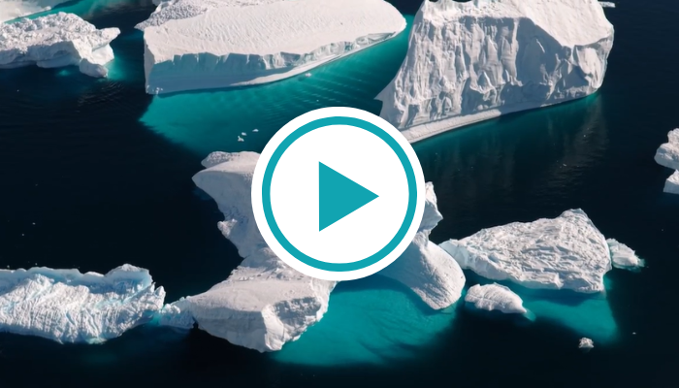
View Video & Download Assets HERE

Sydney, Australia – April 30, 2026 — Aurora Expeditions has delivered its largest Antarctic season to date, operating 30 voyages, facilitating an estimated 819 landings, and welcoming a 30% increase in expeditioners, representing 56 nationalities.

The 2025/26 programme was underpinned by the launch of the company’s third expedition vessel, Douglas Mawson, in Sydney in November, ahead of its inaugural Antarctic season. This was the first time in its 35-year history, Aurora operated three ships simultaneously in Antarctica, expanding access and choice for expeditioners.

The season also marked a long-anticipated return to East Antarctica after 15 years, alongside the introduction of ‘Active Antarctica’ voyages, featuring 14 included activities designed to further deepen immersive, activity-led exploration.

RECORD-BREAKING EXPLORATION
A defining moment came as Douglas Mawson reached 78º 44.405' south, marking a new World Record of the southernmost voyage in history — a testament to the company’s expedition heritage and commitment to responsible exploration.

Aurora also recorded 2,835 polar plunges, delivered 269 onboard lectures, and saw expeditioners contribute thousands of hours to onboard Citizen Science programmes — supporting initiatives such as whale and seabird monitoring, oceanographic data collection, and polar ecosystem observation.

INNOVATION FOR RESPONSIBLE TRAVEL
The programme also introduced several industry-firsts that reinforce Aurora’s position as a leader in responsible expedition travel.

Aurora became the first expedition operator to bring both AI-powered routing technology and microplastic filtration systems to Antarctica, enhancing operational efficiency while contributing to ongoing environmental research and protection efforts. The season also marked the introduction of drone-supported scouting, used to assist bridge teams with real-time ice and landing site assessment, helping to enhance navigation safety and inform expedition planning.

“This season represents a significant milestone for Aurora Expeditions,” said Michael Heath, CEO of Aurora Expeditions. “Delivering 30 voyages to Antarctica — including a return to East Antarctica - and operating three ships in the region for the first time — reflects both our heritage and how we continue to evolve. It also reflects growing demand for deeper, more immersive exploration. Our focus remains on delivering these experiences in a responsible way.”

Aurora Expeditions’ 2026/27 Antarctic voyages are now open for booking. Visit aurora-expeditions.com or speak to your local travel agent to learn more.

~ENDS~

About Aurora Expeditions
Aurora Expeditions is an award-winning Australian-owned adventure travel company that has pioneered experiential travel for 35 years. A Certified B Corporation™️, a commitment to the protection and preservation of our planet is at the heart of each experience.

Founded on the guiding principles of adventure and endless exploration, our carefully curated small-ship voyages offer immersive activities, more time off ship and thoughtful enrichment programs in some of the planet’s most remote and incredible places.
Aurora’s three purpose-built small ships, Greg Mortimer, Sylvia Earle and Douglas Mawson are designed for global discovery.

